Teacher Notes for “Carbon Cycles and Energy Flow through Ecosystems”

In this analysis and discussion activity, students learn why the biosphere requires a continuous inflow of energy, but does not need an inflow of carbon atoms. Students analyze how the process of photosynthesis illustrates the general principles of conservation of matter and the second Law of Thermodynamics. Then, students analyze how carbon cycles and energy flow through ecosystems result from photosynthesis, biosynthesis, cellular respiration, and the trophic relationships in food webs. Thus, students learn how important ecological phenomena result from processes at the molecular, cellular and organismal levels.

As background for this activity, students should have a basic understanding of cellular respiration, photosynthesis, and food webs. For this purpose, we recommend these activities:
- “Photosynthesis and Cellular Respiration – Understanding the Basics of Bioenergetics and Biosynthesis” (http://serendipstudio.org/exchange/bioactivities/photocellrespir) and the introductory activities recommended in the Teacher Notes for that activity.
- “Food Webs – Understanding What Happened When Wolves Returned to Yellowstone” (https://serendipstudio.org/sci_edu/waldron/#foodweb)

Learning Goals
Learning Goals related to Next Generation Science Standards
Students will gain understanding of Disciplinary Core Idea LS2.B, Cycles of Matter and Energy Transfer in Ecosystems:
“Plants or algae form the lowest level of the food web. At each link upward in a food web, only a small fraction of the matter consumed at the lower level is transferred upward, to produce growth and release energy in cellular respiration at the higher level. Given this inefficiency, there are generally fewer organisms at higher levels of a food web. Some matter reacts to release energy for life functions, some matter is stored in newly made structures, and much is discarded. The chemical elements that make up the molecules of organisms pass through food webs and into and out of the atmosphere and soil, and they are combined and recombined in different ways. At each link in an ecosystem, matter and energy are conserved.”
“Photosynthesis and cellular respiration are important components of the carbon cycle, in which carbon is exchanged among the biosphere, atmosphere, oceans and geosphere through chemical, physical, geological, and biological processes.”

Students engage in Scientific Practices:
- “Constructing Explanations – Apply scientific ideas, principles, and/or evidence to provide an explanation of phenomena…”
- “Developing and Using Models – Develop, revise, and/or use a model based on evidence to illustrate and/or predict the relationships between systems or between components of the system.”

The Crosscutting Concept, “Energy and Matter: Flows, Cycles and Conservation” is a central theme of this activity. Specifically, this activity helps students to understand that:
- “Changes of energy and matter in a system can be described in terms of energy and matter flows into, out of and within that system.”
- “Energy cannot be created or destroyed – only moves between one place and another place, between objects and/or fields, or between systems.”
- “Energy drives the cycling of matter within and between systems.”
This activity helps to prepare students for the Performance Expectations:
- HS-LS2-4. “Use a mathematical representation to support claims for the cycling of matter and flow of energy among organisms in an ecosystem.”
- HS-LS2-5. “Develop a model to illustrate the role of photosynthesis and cellular respiration in the cycling of carbon among the biosphere, atmosphere, hydrosphere and geosphere.”

Specific Content Learning Goals
- The carbon cycle results from the processes of:
- photosynthesis, which moves carbon atoms from CO₂ to small organic molecules, and biosynthesis, which produces larger, more complex organic molecules;
- eating by animals and consumption of dead organic matter by decomposers; these processes move carbon in organic molecules from one organism to another;
- cellular respiration, which moves carbon atoms from organic molecules to CO₂.
- The following general principles apply to all biological processes, including photosynthesis, biosynthesis and cellular respiration.
- The atoms in molecules can be rearranged into other molecules, but atoms cannot be created or destroyed.
- Energy is neither created nor destroyed by biological processes.
- Energy can be transformed from one type to another (e.g. the energy in sunlight can be transformed to chemical energy in glucose).
- During energy transfers and transformations, some of the input energy is transformed to heat energy.
- Energy flows through ecosystems. Photosynthesis transforms sunlight to chemical energy in organic molecules (e.g. glucose). In cellular respiration, glucose is one input for reactions that provide the energy to make ATP from ADP + P. ATP provides the energy for many biological processes. Each of these biological processes produces heat. Heat cannot be used as the input energy for photosynthesis and instead is ultimately radiated out to space. Therefore, the biosphere, with all of the Earth’s living organisms, depends on constant input of light energy from the sun. In contrast, the earth does not receive a significant inflow of carbon atoms, and this is not a problem because the carbon cycle constantly recycles carbon atoms.
Instructional Suggestions and Background Information
If your students are learning online, we recommend that they use the Google Doc version of the Student Handout available at https://serendipstudio.org/exchange/bioactivities/carboncycle. To answer questions 4c and 6b, students can either print the relevant pages, draw on those and send you pictures, or they will need to know how to modify a drawing online. They can double-click on the relevant drawing in the Google Doc, which will open a drawing window. Then, they can use the editing tools to add lines, shapes, and text boxes. You may want to revise the GoogleDoc or Word document to prepare a version of the Student Handout that will be more suitable for your students; if you do this, please check the format by viewing the PDF.

To maximize student learning, we recommend that you have your students work in pairs to complete groups of related questions. Student learning is increased when students discuss scientific concepts to develop answers to challenging questions; students who actively contribute to the development of conceptual understanding and question answers gain the most (https://education.asu.edu/sites/default/files/the_role_of_collaborative_interactions_versus_individual_construction_on_students_learning_of_engineering_concepts.pdf). After students have worked together to answer a group of related questions, we recommend having a class discussion that probes student thinking and helps students to develop a sound understanding of the concepts and information covered.

A key for this activity is available upon request to Ingrid Waldron (iwaldron@upenn.edu). The following paragraphs provide additional instructional suggestions and background biology information – some for inclusion in your class discussions and some to provide you with relevant background that may be useful for your understanding and/or for responding to student questions.

Question 1 is intended to stimulate students to think about questions that will be explored in the rest of this activity. By the time students reach question 8, they should be prepared to provide an accurate explanation of why the biosphere requires a constant input of energy from the sun, but does not need an inflow of carbon atoms. You may want to clarify that, although we speak of energy flow, energy is always a property of a physical system and not a disembodied separate substance. For example, increased heat energy corresponds to increased random motion of molecules.

The equation for photosynthesis follows the common convention that photosynthesis produces glucose. To be more specific, photosynthesis produces three-carbon molecules which are converted to glucose and fructose which can be combined to produce sucrose (which is transported throughout the plant).

The general principle in question 2b is the familiar Conservation of Matter, stated in a form that will be easier for students to apply to the analysis of photosynthesis. The general principles in question 2c will be familiar as the first Law of Thermodynamics and an implication of the second Law of Thermodynamics. Additional information about energy and the processes of photosynthesis and cellular respiration is provided in “Cellular Respiration and Photosynthesis – Important Concepts, Common Misconceptions, and Learning Activities” (http://serendipstudio.org/exchange/bioactivities/cellrespiration; this includes an explanation of the estimate that cellular respiration of one molecule of glucose results in the production of ~29 ATP).
The curved arrows in the equations for cellular respiration and biosynthesis represent coupled chemical reactions in which one reaction provides the energy needed for the other reaction. After question 3c, you may want to add the following question to remind students that animal cells use digested carbohydrate, fat and protein food molecules as inputs for cellular respiration.
3d. How do animal cells get the sugar molecules for cellular respiration?

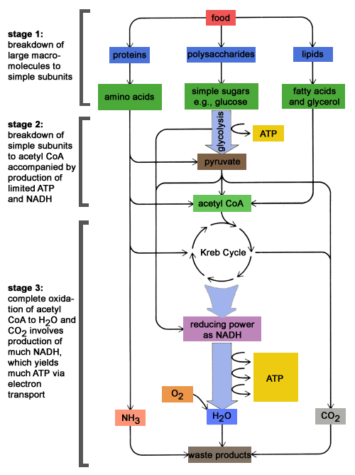
(http://schoolworkhelper.net/wp-content/uploads/2010/07/catabolism.gif)

Students may be puzzled by the idea that photosynthesis and cellular respiration produce heat, since leaves generally do not feel warm. This can be explained by considering that only a relatively small amount of heat is produced by the biological processes in a single leaf and other processes such as transpiration tend to cool leaves. If your students are familiar with compost piles, you may want to discuss how compost piles heat up due to the metabolic activity of decomposers.

The following equation and diagram provide additional information about how cellulose is synthesized from glucose. The details of this reaction are not important for our purposes; the reaction is included only to illustrate an example of biosynthesis. The chart on the top of page 2 of the Student Handout includes the hydrolysis of ATP to provide the energy for biosynthesis.
n(HO–C₆H₁₀O₄–OH) → H–(O–C₆H₁₀O₄)_{n}–OH + (n – 1)H₂O
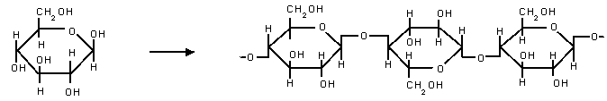
(http://www.easychem.com.au/production-of-materials/biomass-research/condensation-polymerisation)

One goal for this activity is to help your students understand the relationships between phenomena observed at different organizational levels, including the relationships between the molecular/cellular processes of cellular respiration, photosynthesis and biosynthesis and the carbon cycle and energy flow observed at the ecosystem level. Students often find it challenging to link their understanding of phenomena observed at different organizational levels, so you may want to reinforce this understanding in your class discussions of the questions in this activity. Questions 4-5 focus on how photosynthesis, biosynthesis, cellular respiration, and trophic relationships contribute to the carbon cycle. Questions 6-7 focus on how the same processes result in the through-flow of energy.

The carbon cycle shown in the Student Handout are simplified to help students clearly understand the basic processes. However, this may leave students puzzled about how CO₂ concentration in the atmosphere has been increasing. To help them understand this, you may want to show them the more complete overview of the carbon cycle shown in the figure below. Resources for teaching about the carbon cycle and global warming are available at https://serendipstudio.org/exchange/bioactivities/ClimateChange and https://serendipstudio.org/exchange/bioactivities/global-warming).
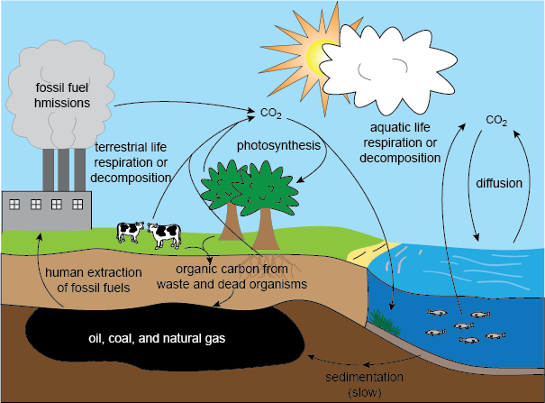
(http://media1.shmoop.com/images/biology/biobook_eco_11.png)

Useful background for this activity is provided in Sections 3 and 4 of Unit 4 of the online textbook available at https://www.learner.org/series/the-habitable-planet-a-systems-approach-to-environmental-science/ecosystems/online-textbook/.

Recommended Follow-Up Activities
Trophic Pyramids
https://serendipstudio.org/exchange/bioactivities/trophicpyr
Students begin this analysis and discussion activity by thinking about what happens to the atoms in the nearly 2000 pounds of food the average American eats each year. This provides a context for students to figure out why the rate of biomass production is higher for the producers than for the primary consumers in an ecosystem. Then, students construct and analyze trophic pyramids. Finally, they apply what they have learned to understanding why more resources are needed to produce meat than to produce an equivalent amount of plant food.

Food and Climate Change – How can we feed a growing world population without increasing global warming?
(https://serendipstudio.org/exchange/bioactivities/global-warming)
In the first section of this activity, students analyze information about climate change, global warming and greenhouse gases. Students learn that correlation does not necessarily imply causation, and they analyze the types of evidence that establish causal relationships. In the next two sections, students analyze carbon cycles, how food production results in the release of greenhouse gases, and the reasons why the production of different types of food results in the release of very different amounts of greenhouse gases. In the last section, students propose and research strategies to feed the world’s growing population without increasing global warming.

Both of these activities support the Next Generation Science Standards.

Sources for Figures in Student Handout
- Earth – modified from https://encrypted-tbn0.gstatic.com/images?q=tbn%3AANd9GcQHIEH_tqHkhCibwvxpllTCgdvEPDMEdc-lPMGFE9nfa6cxldvcr-vWY5EIA59yptGN0sxyQRqpJmIz6Mh_Bj4w6-FnviSgNR2S7A&usqp=CAU&ec=45690274
- Giraffe carbon cycle – modified from http://www.bbc.co.uk/schools/gcsebitesize/science/images/bi01002.gif
Other figures were created by the authors.

By Drs. Ingrid Waldron and Lori Spindler, Department of Biology, University of Pennsylvania. © 2021. The Student Handout and these Teacher Preparation Notes are available at https://serendipstudio.org/exchange/bioactivities/carboncycle.
Quotations are from http://www.nextgenscience.org/sites/default/files/HS%20LS%20topics%20combined%206.13.13.pdf
We use biosynthesis to refer to the processes that use the product of photosynthesis to make other types of organic molecules. Some sources use the term biosynthesis to include photosynthesis.
To draw a shape - At the top of the page, find and click Shape. - Choose the shape you want to use. - Click and drag on the canvas to draw your shape. To insert text - At the top of the page, click Insert. - To place text inside a box or confined area, click Text Box and drag it to where you want it. - Type your text. - You can select, resize and format the word art or text box, or apply styles like bold or italics to the text. When you are done, click Save and Close.
We have used somewhat simplified language to discuss energy, and you may prefer to follow the more sophisticated recommendations for helping students understand energy in the NSTA Press book, “Teaching Energy Across the Sciences K-12”.
The biosynthesis of many types of organic molecules requires minerals in addition to the products of photosynthesis. For plants, these minerals are taken up from the soil. For example, plants use mineral sources of nitrogen (e.g. NH₄⁺), together with carbon-containing molecules to make amino acids that can be joined together to form proteins. Humans and other mammals obtain minerals primarily from the food they eat.

